Cairo University  
Faculty of Computers and Artificial Intelligence



**CS251**

FORLOOP

Software Design Specifications

Version 2.1

|  |  |
| --- | --- |
| **Name** | **Email** |
| Mohamed Foda Abdullah | mfoda80@yahoo.com |
| Aya Gamal Mohamed Hussien | ayagolden2017@gmail.com |

6 of 2021

Contents

Team3

Document Purpose and Audience3

System Models3

I. Class Diagram(s)4

II. Class Descriptions5

III. Sequence diagrams6

Class - Sequence Usage Table11

IV. State Diagram Error: Reference source not found

ToolsError: Reference source not found

Ownership Report13

# Team

|  |  |  |  |  |
| --- | --- | --- | --- | --- |
| **ID** | **Name** | **Email** | **Mobile** | **Group** |
| 20130213 | Mohamed Foda Abdullah | memomohamedwarth@gmail.com | 01114391169 | G1 |
| 20190118 | Aya Gamal Mohamed Hussien | ayagolden2017@gmail.com | 01069499654 | G1 |

# Document Purpose

* The purpose of this document is to clarify software requirements that are agreed upon by the stakeholders by specifying the needed functionalities of the software to minimize development time and cost by making the requirements clear**.**

# Audience

* Software Development Team ● Stakeholders

# System Models

## Class Diagram(s)

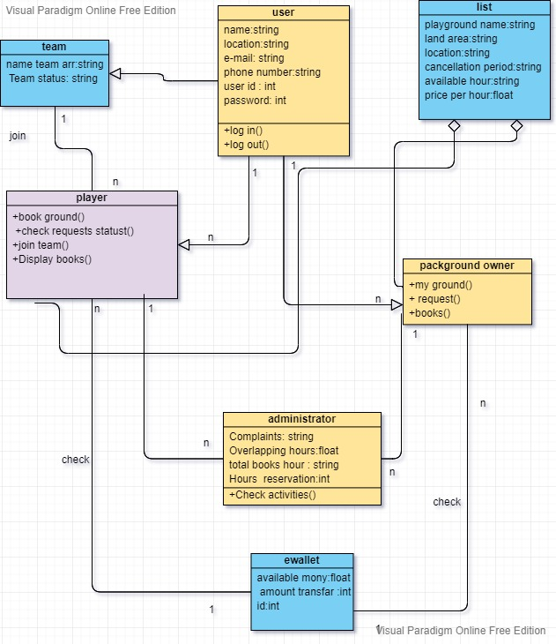

## II. Class Descriptions

| **Class ID** | **Class Name** | **Description & Responsibility** |
| --- | --- | --- |
| 1. | user | Class makes any person log in or log out |
| 2. | Playground owner | Class makes playground owner add or edit list of playground |
| 3. | player | Class makes player book nearby ground |
| 4. | administrator | Class checks information of user (owner or player) |
| 5. | list | Class includes all information about ground and available hour that user can book or add |
| 6. | team | Class allows player to join with team and contain all information about member of team |
| 7. | ewallet | Class allows user(owner or player)to check available money |

## III. Sequence diagrams

1. Playground Owner/Player Sign-up

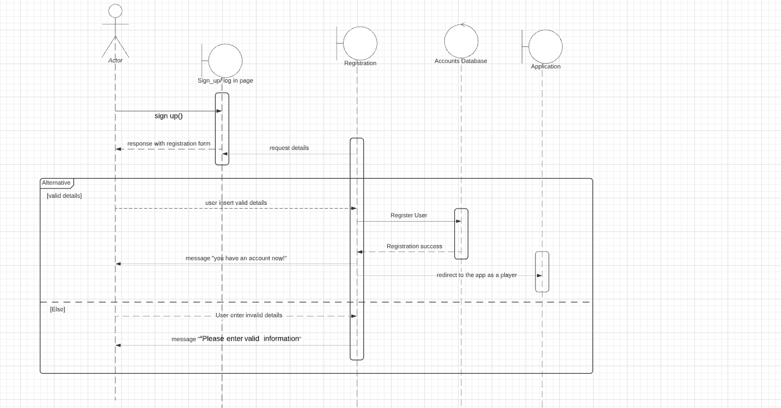

1. Add/Edit Playground

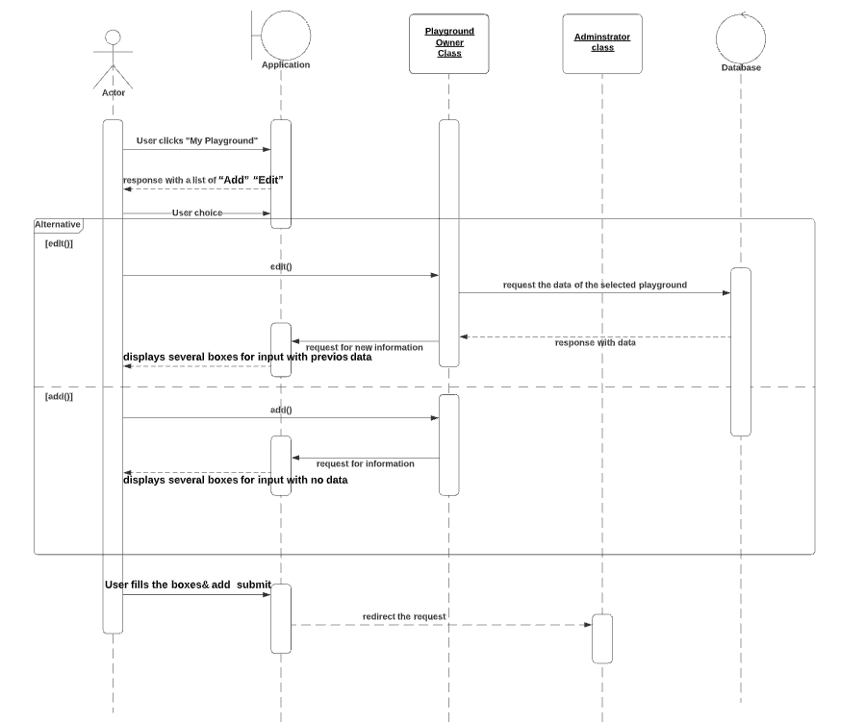

**3.** Display requests & accept a request or deny it:

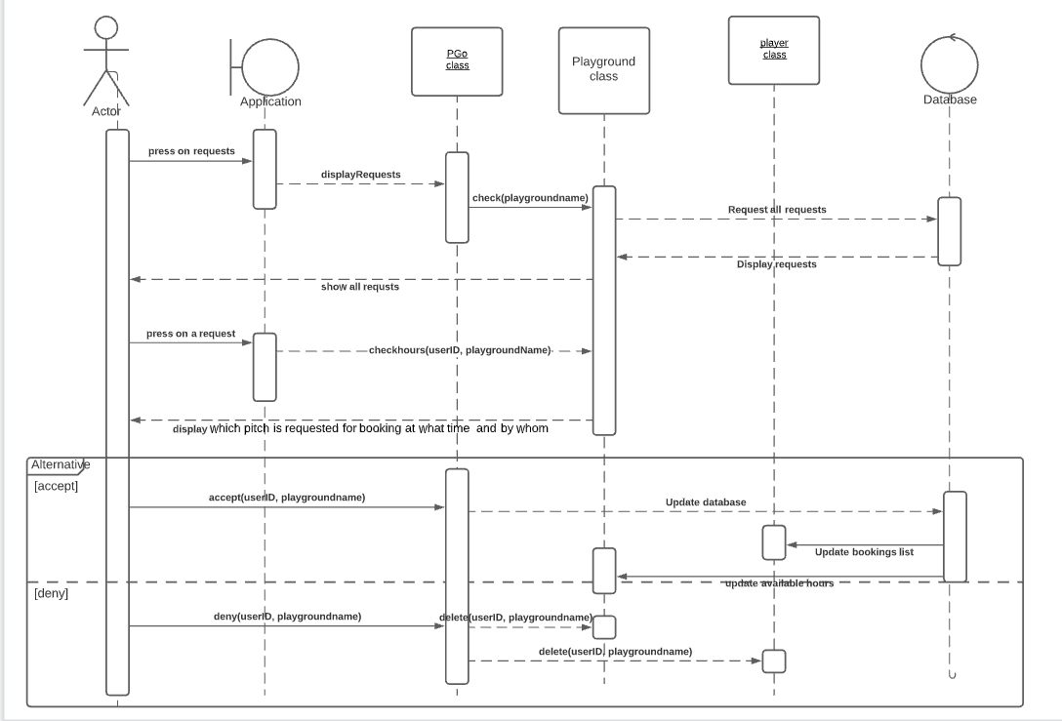

**4.** Check eWallet & transfer money

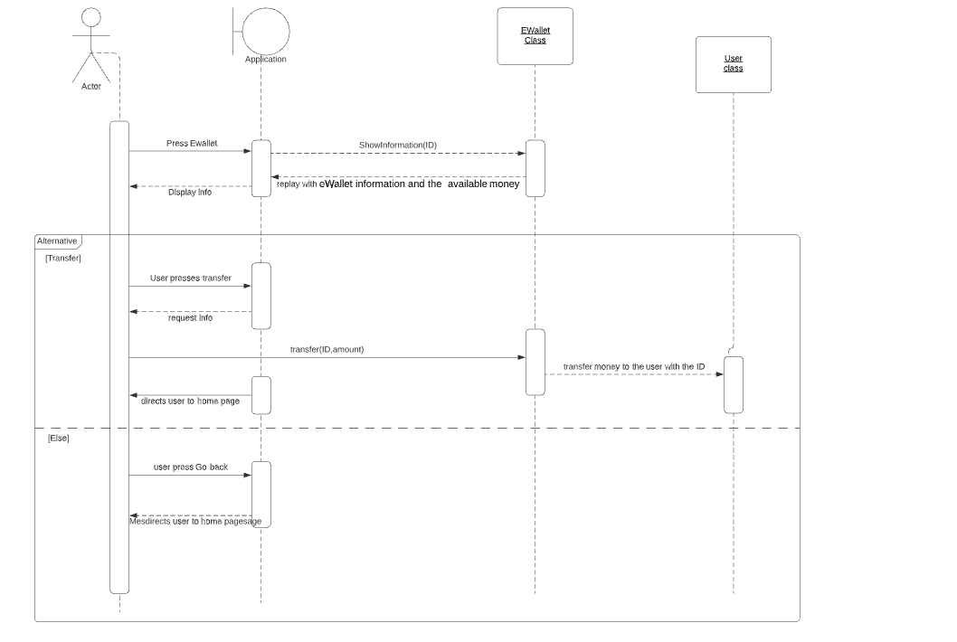

### Class - Sequence Usage Table

| **Sequence Diagram** | **Classes Used** | **All Methods Used** |
| --- | --- | --- |
| 1. Sign up field | Class User  Class Player | signUp() |
| 1. Edit Playground field | Class Playground Owner  Administrator class | edit(): return the data entered to the playground with enabling the user to update it.  add()  check() |
| 1. Display requests & accept a request or deny it field | Playground Owner class  Player class  Playground class | check(playgroundname)  checkhours(userID, playgroundName)  accept(userID, playgroundname)  deny(userID, playgroundname)  delete(userID, playgroundname) |
| 1. Check eWallet & transfer money | Player class  User class  EWallet class | ShowInformation(ID)  transfer(ID,amount) |

# State Machine Diagram

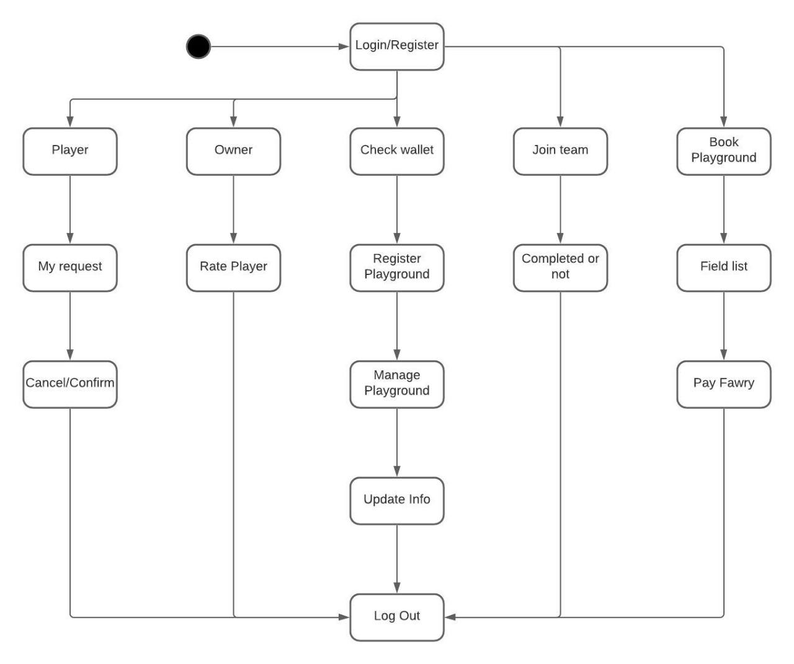

# Tools

* **Lucidchart.com**
* **Visual paradigam online free edition**

# Ownership Report

|  |  |
| --- | --- |
| **Item** | **Owners** |
| Mohamed Foda Abdullah | **class diagram**  **class description**  **State Diagram** |
| Aya Gamal Mohamed | **sequence diagrams**  **sequence table** |